Consistency of the MLE for Poisson distribution

**Objective**: The primary purpose is to explore the consistency of the maximum likelihood estimator (${\hat{λ}}_{n}$) for the Poisson distribution as the sample size ($n$) increases.



**Motivation:** A data scientist has conducted research which suggests the number of calls in an answering service approaches a Poisson distribution and the telephonist, on the average, handles six calls every two minutes $\left(λ^{*}=6\frac{calls}{two minutes}\right)$.

**Task:** Follow the subsequent steps to examine the consistency of ${\hat{λ}}_{n}$.

1. Assume that the number of calls addressed by the telephone operator indeed resembles a Poisson distribution.
2. Compute the average number of calls ($λ$) answered in a minute from the given information, use the three-simple rule to obtain $λ$.
3. Open the Shiny app given in the URL:

<http://gauss.medellin.unal.edu.co:3838/fhernanb/convergencia2>

1. Using the Shiny app, select the Poisson distribution, the real rate $\left(λ=3 \frac{calls}{minute}\right)$ and $δ=0.07$.
2. Fix the sample size at $n=50, 100, 200, 560, 1000, 2400, 4700$ and fill the gaps in Table 1 by using the results from the Shiny app.

Table 1. Number of samples and proportions when the maximum likelihood estimator is within or outside the interval $\left(λ±δ\right)$.

|  |  |  |  |  |
| --- | --- | --- | --- | --- |
| Sample size $$n$$ | Number of samples on which $$λ-δ<{\hat{λ}}_{n}<λ+δ$$ | Number of samples  on which ${\hat{λ}}_{n}≤λ-δ$ or |  |  |
| 50 | 2301 |  | 0.23 |  |
| 100 |  |  |  |  |
| 200 |  | 5839 |  | 0.584 |
| 560 |  |  |  |  |
| 1000 |  |  |  |  |
| 2400 |  |  |  |  |
| 4700 |  |  |  |  |

1. According to the data gathered:

* What can one infer with regard to the pattern observed? ______________________________________________________________________________________________________________________________________________________________________________________________________________________________________________________________________________________________________________________________________________________________
* Can one affirm that is close to with high probability (when is large)? ______________________________________________________________________________________________________________________________________________________________________________________________________________________________________________________________________________________________________________________________________________________________

1. Replicate numerals 4 and 5 with higher values for $δ$. What can one conclude about the convergence quickness of ${\hat{λ}}_{n}$ as $δ$ rises? __________________________________________________________________________________________________________________________________________________________________________________________________________________________________________________________________________________________________________________________________________________________________________________________________________________________________________________________________

Consistency of the MLE for Geometric distribution

**Objective**: The primary purpose is to explore the consistency of the maximum likelihood estimator (${\hat{π}}_{n}$) for the Geometric distribution as the sample size ($n$) increases.

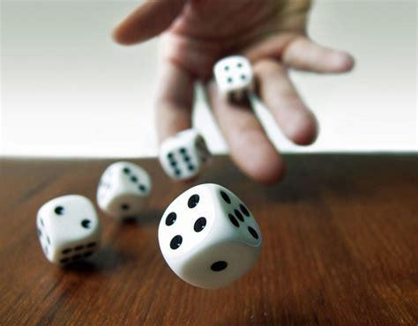

**Motivation:** From grandparents' expertise, when a loaded dice is thrown repeatedly on a board game, the Geometric distribution might be used for modeling the number of failures until the first time a “6” appears with success probability equals 0.3.

**Task:** Follow the subsequent steps to examine the consistency of ${\hat{π}}_{n}$.

1. Assume that the number of failures until the first time a “6” appears truly resembles a Geometric distribution.
2. Open the Shiny app given in the URL <https://tinyurl.com/shinymle>.
3. Using the Shiny app, select the Geometric distribution, the real probability ($π=0.3$) and $δ=0.07$.
4. Fix the sample size at $n=50, 100, 200, 560, 1000, 2400, 4700$ and fill the gaps in Table 2 by using the results from the Shiny app.

Table 2. Number of samples and proportions when the maximum likelihood estimator is within or outside the interval $\left(π±δ\right)$.

|  |  |  |  |  |
| --- | --- | --- | --- | --- |
| Sample size $$n$$ | Number of samples on which $$π-δ<{\hat{π}}_{n}<π+δ$$ | Number of samples  on which ${\hat{π}}_{n}≤π-δ$ or |  |  |
| 50 | 9437 |  | 0.944 |  |
| 100 |  |  |  |  |
| 200 |  | 1 |  | 0 |
| 560 |  |  |  |  |
| 1000 |  |  |  |  |
| 2400 |  |  |  |  |
| 4700 |  |  |  |  |

1. According to the data gathered:

* What can one infer with regard to the pattern observed? ______________________________________________________________________________________________________________________________________________________________________________________________________________________________________________________________________________________________________________________________________________________________
* Can one affirm that ${\hat{π}}_{n}$ is close to $π=0.3$ with high probability (when $n$ is large)? ______________________________________________________________________________________________________________________________________________________________________________________________________________________________________________________________________________________________________________________________________________________________

1. Replicate numerals 3 and 4 with higher values for $δ$. What can one conclude about the convergence quickness of ${\hat{π}}_{n}$ as $δ$ rises? __________________________________________________________________________________________________________________________________________________________________________________________________________________________________________________________________________________________________________________________________________________________________________________________________________________________________________________________________

Consistency of the MLE for Exponential distribution

**Objective**: The primary purpose is to explore the consistency of the maximum likelihood estimator (${\hat{ϕ}}_{n}$) for the Exponential distribution as the sample size ($n$) increases.

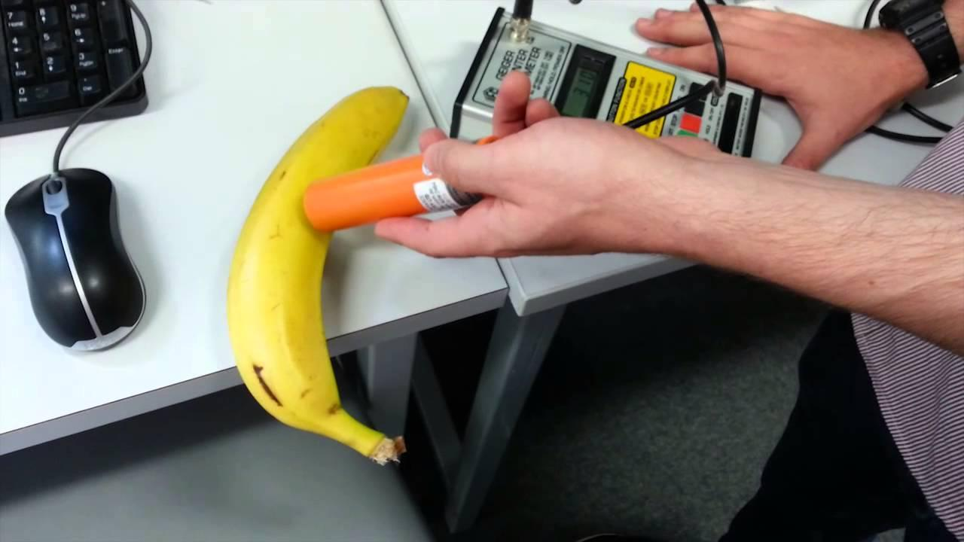

**Motivation:** An experimental physicist claims that the lapse of time between detections of an unusual particle by a Geiger counter has an Exponential distribution with mean time equals 0.25 hours.

**Task:** Follow the subsequent steps to examine the consistency of ${\hat{ϕ}}_{n}$.

1. Assume that the amount of time between detections of an unusual particle, in effect, has an Exponential distribution.
2. Compute the rate ($ϕ$) from the given information.
3. Open the Shiny app given in the URL <https://tinyurl.com/shinymle>.
4. Using the Shiny app, select the Exponential distribution, the real rate $\left(ϕ=\frac{1}{0.25}=4\frac{detections}{hour}\right)$ and $δ=0.07$.
5. Fix the sample size at $n=50, 100, 200, 560, 1000, 2400, 4700$ and fill the gaps in Table 3 by using the results from the Shiny app.

Table 3. Number of samples and proportions when the maximum likelihood estimator is within or outside the interval $\left(ϕ±δ\right)$.

|  |  |  |  |  |
| --- | --- | --- | --- | --- |
| Sample size $$n$$ | Number of samples on which $$ϕ-δ<{\hat{ϕ}}_{n}<ϕ+δ$$ | Number of samples  on which ${\hat{ϕ}}_{n}≤ϕ-δ$ or |  |  |
| 50 | 948 |  | 0.095 |  |
| 100 |  |  |  |  |
| 200 |  | 8094 |  | 0.809 |
| 560 |  |  |  |  |
| 1000 |  |  |  |  |
| 2400 |  |  |  |  |
| 4700 |  |  |  |  |

1. According to the data gathered:

* What can one infer with regard to the pattern observed? ______________________________________________________________________________________________________________________________________________________________________________________________________________________________________________________________________________________________________________________________________________________________
* Can one affirm that is close to with high probability (when is large)? ______________________________________________________________________________________________________________________________________________________________________________________________________________________________________________________________________________________________________________________________________________________________

1. Replicate numerals 4 and 5 with higher values for $δ$. What can one conclude about the convergence quickness of ${\hat{ϕ}}_{n}$ as $δ$ rises? __________________________________________________________________________________________________________________________________________________________________________________________________________________________________________________________________________________________________________________________________________________________________________________________________________________________________________________________________

To conclude, infer curves which illustrate the convergence swiftness of the MLEs of the parameters regarded throughout this questionnaire from acquired information in Tables 1, 2 and 3 and color them according to the imposed colors for the distributions.

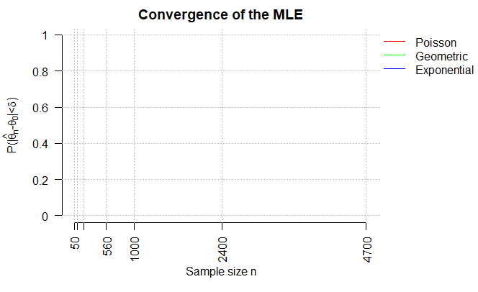

Figure 1. Template to illustrate theconvergence swiftness of the MLEs.